**ANÁLISIS DE CALIDAD DEL AGUA Y PATRONES DE DIVERSIDAD DE INSECTOS ACUÁTICOS DE DOS TEMPORADAS AMBIENTALES EN LAS CUENCAS CUITZMALA Y PURIFICACIÓN, MÉXICO**

Andrés Felipe Grajales-Andica1; Luis Manuel Martínez-Rivera1; Francia Elizabeth Rodríguez-Contreras1; y Claudia Irene Ortiz-Arrona1

1Departamento de Ecología y Recursos Naturales, Centro Universitario de la Costa Sur, Universidad de Guadalajara, Av. Independencia Nacional 151, 48900 Autlán de Navarro, Jalisco, México.

*Autor de correspondencia: [lmanuel.martinez@academicos.udg.mx](mailto:lmanuel.martinez@academicos.udg.mx)

**Material suplementario**

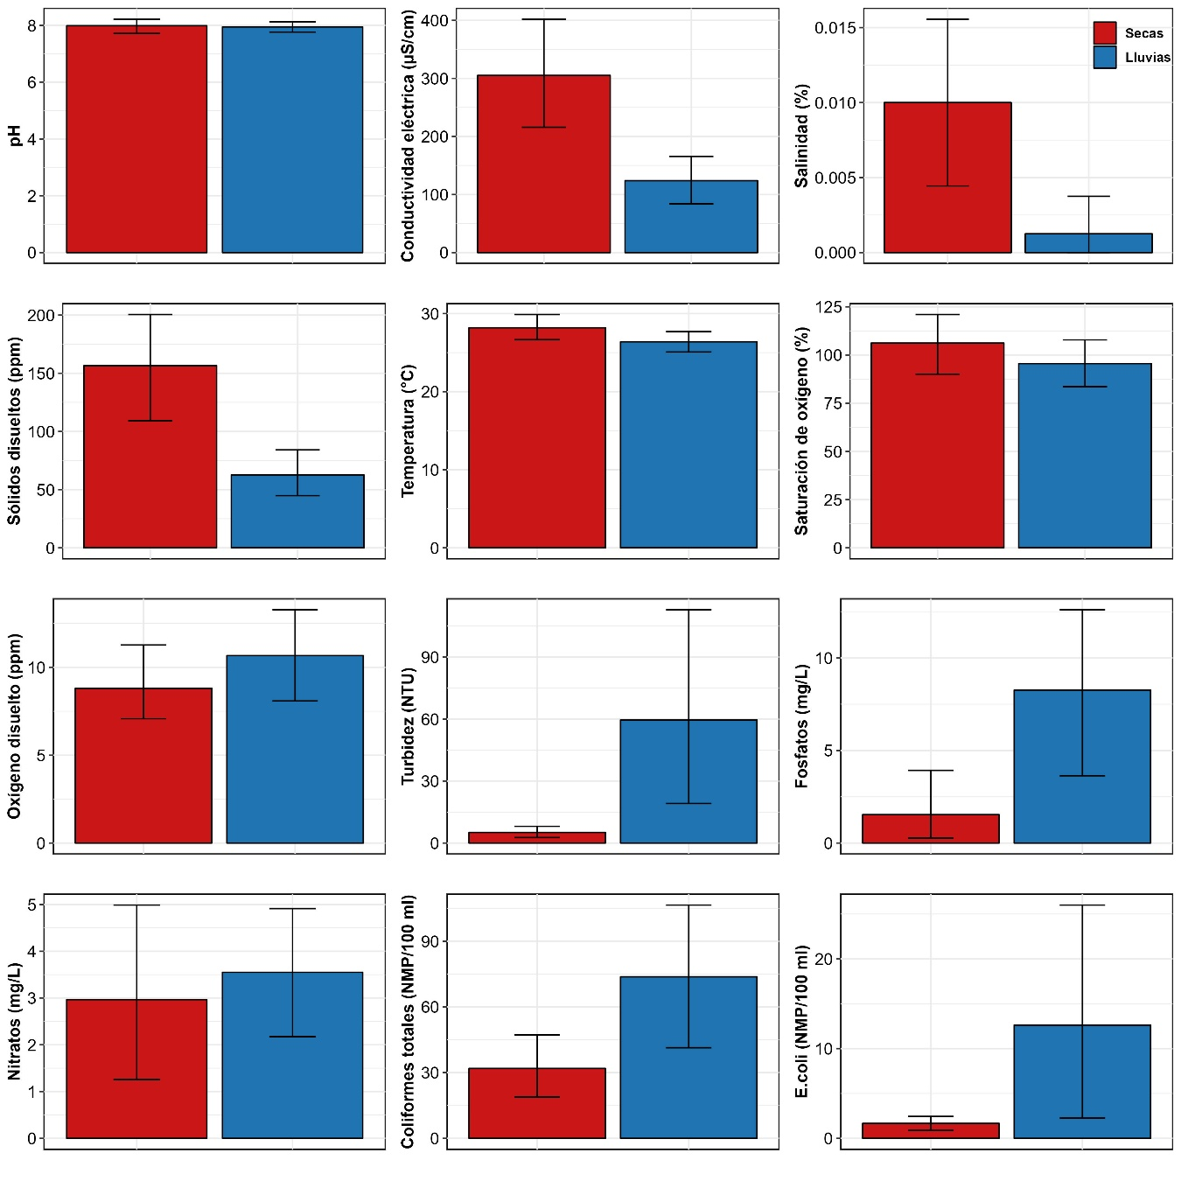

**Fig. S1.** Variables de la calidad del agua comparadas entre la temporada seca y de lluvias.

**Tabla S1.** Familias de insectos acuáticos y sus abundancias colectadas en la temporada seca y de lluvias.

|  |  |  |  |
| --- | --- | --- | --- |
| **Orden** | **Familia** | **Secas** | **Lluvias** |
| **Coleoptera** | Dryopidae | 29 | 6 |
| Dytiscidae | 17 | 0 |
| Elmidae | 2183 | 110 |
| Gyrinidae | 0 | 1 |
| Hydraenidae | 17 | 0 |
| Hydrophilidae | 103 | 5 |
| Hydroscaphidae | 1 | 0 |
| Lampyridae | 0 | 2 |
| Lutrochidae | 122 | 1 |
| Noteridae | 0 | 1 |
| Psephenidae | 179 | 5 |
| Ptilodactylidae | 26 | 1 |
| Scirtidae | 4 | 0 |
| Staphylinidae | 5 | 14 |
| **Diptera** | Athericidae | 2 | 0 |
| Ceratopogonidae | 193 | 5 |
| Chironomidae | 3070 | 247 |
| Culicidae | 87 | 0 |
| Dixidae | 3 | 0 |
| Empididae | 5 | 2 |
| Ephydridae | 2 | 0 |
| Muscidae | 1 | 0 |
| Psychodidae | 30 | 3 |
| Simuliidae | 15 | 1257 |
| Stratiomydae | 56 | 0 |
| Tabanidae | 12 | 1 |
| Tipulidae | 61 | 2 |
| **Ephemeroptera** | Baetidae | 1537 | 727 |
| Caenidae | 16 | 0 |
| Heptageniidae | 8 | 0 |
| Leptohyphidae | 2578 | 213 |
| Leptophlebiidae | 656 | 157 |
| Oligoneuriidae | 0 | 184 |
| **Hemiptera** | Belostomatidae | 14 | 3 |
| Corixidae | 97 | 0 |
| Gerridae | 16 | 1 |
| Hebridae | 33 | 0 |
| Hydrometridae | 1 | 0 |
| Naucoridae | 101 | 41 |
| Notonectidae | 1 | 0 |
| Ochteridae | 1 | 0 |
| Pleidae | 6 | 0 |
| Veliidae | 19 | 23 |
| **Lepidoptera** | Crambidae | 76 | 1 |
| **Megaloptera** | Corydalidae | 36 | 8 |
| **Neuroptera** | Sisyridae | 4 | 0 |
| **Odonata** | Calopterygidae | 2 | 4 |
| Coenagrionidae | 98 | 5 |
| Gomphidae | 30 | 25 |
| Libellulidae | 15 | 12 |
| Platystictidae | 7 | 0 |
| **Plecoptera** | Perlidae | 52 | 1 |
| **Trichoptera** | Calamoceratidae | 78 | 2 |
| Helicopsychidae | 225 | 0 |
| Hydropsychidae | 229 | 38 |
| Hydroptilidae | 146 | 2 |
| Leptoceridae | 44 | 1 |
| Odontoceridae | 1 | 0 |
| Philopotamidae | 891 | 3 |
| Xiphocentronidae | 2 | 0 |
| **Total** |  | 13243 | 3114 |

**Tabla S2.** Resultados del Análisis de Especies Indicadoras (IndVal) en la temporada seca y de lluvias. Se proporcionan los valores de los indicadores y los valores p asociados, así como las puntuaciones de especificidad (A) y sensibilidad (B).

|  |  |  |  |  |  |
| --- | --- | --- | --- | --- | --- |
| **Temporada** | **Familia indicadora** | **Valor indicador** | **A** | **B** | **p-valor** |
| Secas | Ceratopogonidae | 0.986 | 0.9717 | 1.0000 | 0.001 |
| Tipulidae | 0.982 | 0.9644 | 1.0000 | 0.001 |
| Hydrophilidae | 0.974 | 0.9482 | 1.0000 | 0.003 |
| Elmidae | 0.973 | 0.9464 | 1.0000 | 0.013 |
| Coenagrionidae | 0.972 | 0.9457 | 1.0000 | 0.001 |
| Helicopsychidae | 0.943 | 1.0000 | 0.8889 | 0.001 |
| Hydroptilidae | 0.936 | 0.9848 | 0.8889 | 0.001 |
| Philopotamidae | 0.880 | 0.9962 | 0.7778 | 0.043 |
| Lutrochidae | 0.813 | 0.9909 | 0.6667 | 0.023 |
| Crambidae | 0.811 | 0.9854 | 0.6667 | 0.023 |
| Leptoceridae | 0.806 | 0.9751 | 0.6667 | 0.038 |
| Ptilodactylidae | 0.799 | 0.9585 | 0.6667 | 0.026 |
| Dytiscidae | 0.745 | 1.0000 | 0.5556 | 0.024 |
| Stratiomydae | 0.745 | 1.0000 | 0.5556 | 0.028 |
| Lluvias | Simuliidae | 0.930 | 0.9895 | 0.8750 | 0.035 |
| Oligoneuriidae | 0.791 | 1.0000 | 0.6250 | 0.015 |