Vargas-López, et.al. (2024) **The influence of Palm Oil Cultivation on Periphyton Communities in Northern Guatemala Streams**

**Supplementary material 1.** Tukey test for Chlorophyll*-a* in sediment samples.

Fit: lme.formula(fixed = Sediment ~ Land.use, data = cloro, random = ~1 |   
 River)  
  
Linear Hypotheses:

|  |  |  |  |  |
| --- | --- | --- | --- | --- |
|  | Estimate Std. | Error | z value | Pr(>|z|) |
| **OP-FO==0** | **9.39262** | **3.28426** | **2.86** | **0.02143\*** |
| OPB-FO==0 | 0.06095 | 3.28426 | 0.019 | 1 |
| **PA-FO==0** | **8.82262** | **2.64786** | **3.332** | **0.00447\*\*** |
| OPB-OP==0 | -9.33167 | 3.88599 | -2.401 | 0.07525. |
| PA-OP==0 | -0.57 | 3.36537 | -0.169 | 0.99824 |
| **PA-OPB==0** | **8.76167** | **3.36537** | **2.603** | **0.04461\*** |

FO OP OPB PA   
 "a" "bc" "ab" "c"

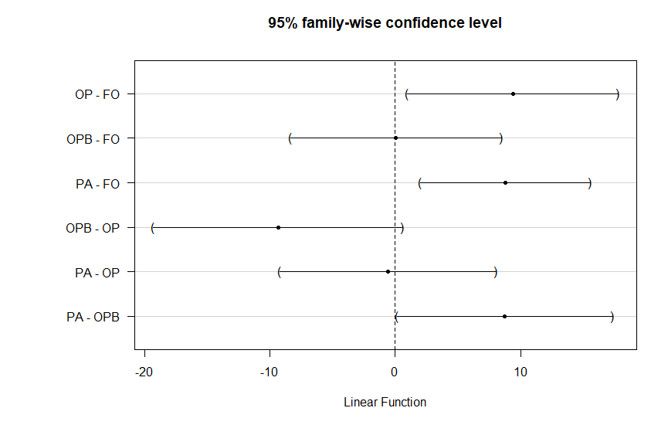

**Supplementary material 2.** List of algae morpho species. Numbers on the right side indicate the number of streams in which they were present.

|  |  |  |  |  |  |  |  |
| --- | --- | --- | --- | --- | --- | --- | --- |
| **Phyllum** | **Order** | **Family** | **Morpho species** | **FO (7)** | **PA (6)** | **OP (3)** | **OPB (3)** |
| **Rhodophyta** | Acrochaetiales | Acrochaetiaceae | *Audinella sp. 1* | **4** |  |  | **3** |
| Batrachospermales | Batrachospermaceae | *Batrachospermun sp. 1* |  | **3** |  |  |
| **Cyanophyta** | Synechococcales | Pseudanabaenaceae | *Pseudanabaena sp. 1* | **5** | **5** | **2** | **3** |
| Nostocales | Stigonemataceae | *Stigonema sp. 1* | **6** |  |  | **1** |
| Nostocaceae | *Nostoc sp. 1* |  | **1** |  |  |
| *Anabaena sp. 1* | **1** | **1** |  |  |
| Oscillatoriales | Oscillatoriaceae | *Phormidium sp. 1* | **5** | **3** | **1** | **1** |
|
| *Oscillatoria sp. 1* | **2** | **5** | **3** |  |
| Spirulinales | Spirulinaceae | *Spirulina sp. 1* | **2** | **1** |  | **2** |
| **Chlorophyta** | Chlorellales | Chlorellaceae | *Dictyosphaerium sp. 1* | **1** |  |  | **1** |
| *Actinastrum sp. 1* | **1** |  |  | **1** |
| Oedogoniales | Oedogoniaceae | *Oedogonium sp. 1* | **6** | **4** | **2** | **1** |
| *Bulbochaete sp. 1* |  | **3** |  |  |
| Chaetophorales | Chaetophoraceae | *Chaetophora sp. 1* | **1** | **3** | **1** |  |
| Sphaeropleales | Scenedesmaceae | *Scenedesmus sp. 1* |  | **2** |  |  |
| *Scenedesmus sp. 2* |  | **1** |  |  |
| No identificadas | | *Morfogénero 1* | **4** |  | **1** |  |
| *Morfogénero 2* | **1** |  | **1** |  |
| *Morfogénero 4* |  | **3** |  |  |
| *Morfogénero 5* | **1** | **3** |  |  |
| **Charophyta** | Desmidiales | Closteriaceae | *Closterium sp. 1* | **4** | **6** |  | **1** |
| *Closterium sp. 2* | **2** | **5** |  | **1** |
| *Closterium sp. 3* | **1** | **3** |  |  |
| Desmidiacea | *Actinotaenium sp. 1* |  | **2** |  |  |
| *Cosmarium sp. 1* | **1** | **3** | **1** | **1** |
| *Cosmarium sp. 2* |  | **4** | **1** |  |
| *Cosmarium sp. 3* | **2** | **3** |  |  |
| *Cosmarium sp. 5* |  | **1** |  |  |
| *Cosmarium sp. 6* |  | **2** |  |  |
| *Cosmarium sp. 7* |  | **3** | **1** |  |
| *Cosmarium sp. 8* |  |  | **1** |  |
| *Pleurotaenium sp. 1* |  | **2** |  |  |
| *Euastrum sp. 1* |  | **2** |  |  |
| *Euastrum sp. 2* |  | **1** |  |  |
| *Desmidium sp. 1* |  | **1** |  |  |
| *Staurastrum sp. 1* |  | **1** |  |  |
| Gonatozygaceae | *Gonatozygon sp. 1* |  | **4** |  |  |
| *Gonatozygon sp. 2* |  | **4** |  |  |
| Peniaceae | *Penium sp. 1* |  | **1** | **1** |  |
| Zygnemataceae | *Spirogyra sp. 1* |  | **4** | **1** |  |
| *Spirogyra sp. 2* |  | **1** |  |  |
| *Morfogénero 1* |  | **1** |  |  |
| Zygnematales | Zygnemataceae | *Mougeotia sp. 1* | **3** | **5** |  | **1** |
| Mesotaeniaceae | *Netrium sp. 1* | **1** | **3** |  |  |
| **Bacillariophyta** | Naviculales | Naviculaceae | *Gyrosigma sp. 1* | **5** | **6** | **3** | **3** |
| *Gyrosigma sp. 2* | **2** | **2** | **2** | **2** |
| *Gyrosigma sp. 3* | **1** | **3** | **3** | **3** |
| *Navicula sp. 1* | **7** | **6** | **3** | **3** |
| *Navicula sp. 2* | **3** | **5** | **3** | **3** |
| Pinnulariaceae | *Pinnularia sp. 1* | **7** | **6** | **3** | **3** |
| *Pinnularia sp. 2* |  | **1** |  |  |
| Stauroneidaceae | *Stauroneis sp. 1* | **4** | **6** | **2** | **3** |
| *Stauroneis sp. 2* | **2** | **2** |  | **1** |
| Amphipleuraceae | *Amphipleura sp. 1* | **4** |  |  |  |
| *Frustalia sp. 1* | **6** | **1** | **1** | **3** |
| Aulacoseirales | Aulacoseiraceae | *Aulacoseira sp. 1* | **1** |  |  | **1** |
| Surirellales | Surirellaceae | *Surirella sp. 1* | **6** | **3** | **1** | **3** |
| *Surirella sp. 2* | **4** | **2** |  |  |
| Eunotiales | Eunotiaceae | *Eunotia sp. 1* | **6** | **4** | **2** | **2** |
| *Eunotia sp. 2* | **5** | **3** | **3** | **3** |
| *Eunotia sp. 3* | **7** | **6** | **3** | **1** |
| *Eunotia sp. 4* | **1** | **2** |  |  |
| Cymbellales | Cymbellaceae | *Cymbella sp. 1* | **6** | **6** | **3** | **3** |
| Gomphonemataceae | *Gomphonema sp. 1* | **7** | **6** | **3** | **3** |
| Fragilariales | Fragilariaceae | *Synedra sp. 1* | **5** | **6** | **3** | **1** |
|  |  | *Tabellaria sp. 1* | **1** | **2** |  |  |
| Bacillariales | Bacillariaceae | *Nitzschia sp. 1* | **1** | **2** | **3** | **2** |
| Cocconeidales | Cocconeidaceae | *Cocconeis sp. 1* | **4** | **1** | **3** | **2** |
| No identificadas | | *Morfogénero 1* | **2** | **2** | **2** | **1** |
| *Morfogénero 2* | **2** | **3** | **3** | **2** |
| *Morfogénero 3* |  | **1** | **1** | **2** |
| *Morfogénero 4* | **5** | **2** | **1** | **3** |
| *Morfogénero 6* | **5** | **1** |  | **2** |

**Supplementary material 3.** Tukey test for Richness.

Fit: lme.formula(fixed = S.Estimator ~ Land.use, data = bio, random = ~1 |   
 River)  
  
Linear Hypotheses:

|  |  |  |  |  |
| --- | --- | --- | --- | --- |
|  | Estimate Std. | Error | z value | Pr(>|z|) |
| OP-FO==0 | 1.6596 | 2.0901 | 0.794 | 0.86 |
| OPB-FO==0 | 0.2907 | 2.0901 | 0.139 | 0.999 |
| **PA-FO==0** | **6.5627** | **1.6851** | **3.894** | **<0.001\*\*\*** |
| OPB-OP==0 | -1.3689 | 2.4731 | -0.554 | 0.9447 |
| PA-OP==0 | 4.9031 | 2.1418 | 2.289 | 0.0985. |
| **PA-OPB==0** | **6.2719** | **2.1418** | **2.928** | **0.0177\*** |

FO OP OPB PA   
 "a" "ab" "a" "b"

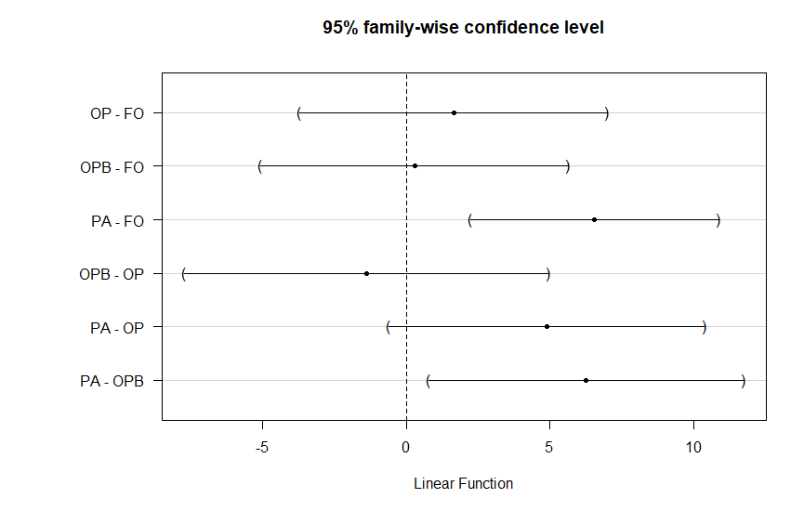

**Supplementary material 4.** Tukey test for Gini-Simpson.

Fit: lme.formula(fixed = D.Estimator ~ Land.use, data = bio, random = ~1 |   
 River)  
  
Linear Hypotheses:

|  |  |  |  |  |
| --- | --- | --- | --- | --- |
|  | Estimate Std. | Error | z value | Pr(>|z|) |
| OP-FO==0 | -0.04337 | 0.027239 | -1.592 | 0.3788 |
| OPB-FO==0 | -0.03792 | 0.027239 | -1.392 | 0.4999 |
| PA-FO==0 | 0.032857 | 0.021961 | 1.496 | 0.4353 |
| OPB-OP==0 | 0.005444 | 0.03223 | 0.169 | 0.9983 |
| **PA-OP==0** | **0.076222** | **0.027912** | **2.731** | **0.0315\*** |
| **PA-OPB==0** | **0.070778** | **0.027912** | **2.536** | **0.0537.** |

FO OP OPB PA   
"ab" "a" "ab" "b"

